Awa Mourtalla Ka

Pr. Hood

ITMM 471

11/5/13

Homework Assignment 3

1. **Analysis of the State of the Project**
2. Draw EVM Graph

Here is the EVM graph. The values for EV, PV and AC will be used to recommend a suitable plan to for the project and to justify the recommendations too.

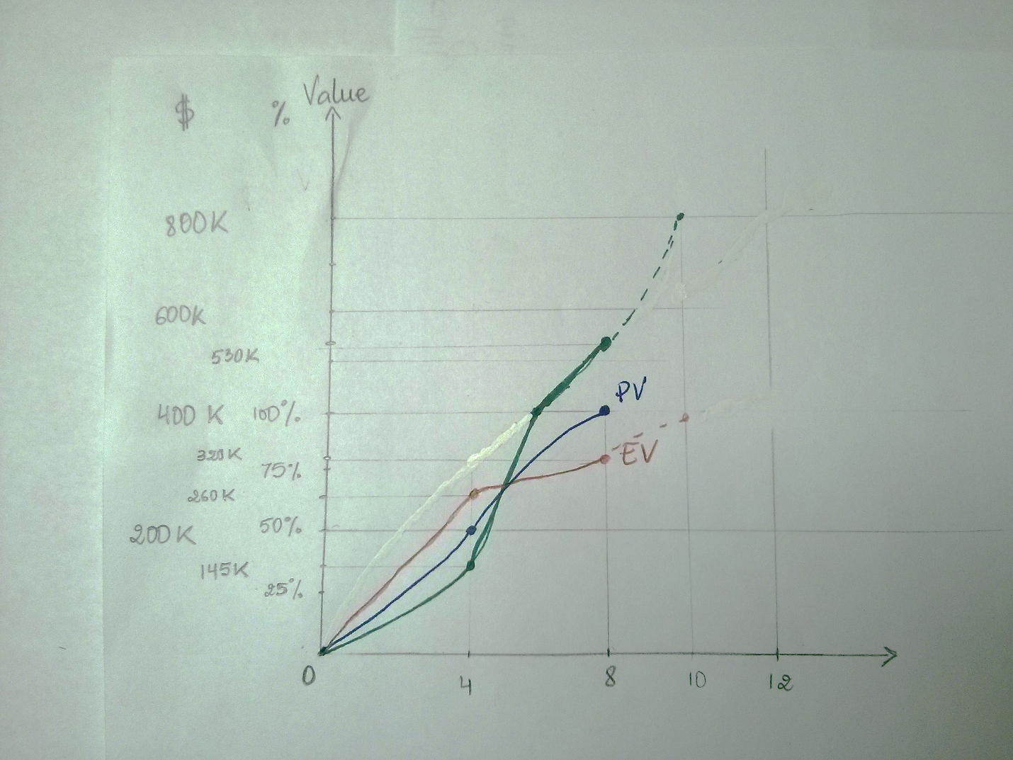

1. Recommend and Justify Next Steps

**SV, CV, CPI and SPI at 4 months:**

SV = EV – PV = 260 – 200 = 60

CV = EV – AC = 260 – 145 = 115

CPI = EV/AC = 260/145 = 1.79

SPI = EV/PV = 260/200 = 1.3

**SV, CV, CPI and SPI at 8 months:**

SV = EV – PV = 320 – 400 = -80

CV = EV – AC = 320 – 530 = -210

CPI = EV/AC = 260/145 = 0.6

SPI = EV/PV = 260/200 = 0.8

To successfully complete the project in 10 months, the schedule has to be condensed which will high impact on the project financially, but the benefits are worth it because the customer is angry and the project has to be done as soon as possible:

* The engineering team needs to be sanctioned and work more hours than they should without getting paid overtime
* The team also has to be reinforced with more competent workers who can work with the given technology, no matter how complex it is.
* Reduce scope of the project
* Hire experts to assist with the project

|  |  |
| --- | --- |
| **Recommendation** | **Cost** |
| Expert Hiring | 200 K |
| Condense schedule by 2 months | 200 K |
| Original Cost of Project | 400 K |
| Total Extra New Cost | 400 K |
| Total Cost of Project | 800 K |

1. **Analyze the State of the Company**
2. Who should be fired?

At first, the project management should be fired at the end of the project because of his poor management skills. He should have been professional enough to not underestimate the project make a better risk exposure assessment. Also, the leader of the engineering team should be fired because he should have made it clear to the PM that the project could not be completed in 8 months and not take the risks.

1. Future Improvements

The following bullet points are specific changes that will be applied in order to successfully complete future projects, which means on time and on budget.

* Make sure the timeframe for the project is adequate
* If not, make sure more time is negotiated before the end of the project.
* Better communication between the PM, engineers and accounting
* More milestones in between significant stages of the project
* Avoid unfamiliar technologies or hire an expert for those technologies
* Train the team to use new technologies before the project starts
* Plot the EVM Graph at every milestone for better assessment of project state.